Installing Promethean Software

If you have a Promethean Board in your classroom, you will need 2 pieces of software installed on your computer in order for the board’s interactive component to be functional. Below are step-by-step instructions on how to download and install Promethean software.

- Visit the Promethean support site at https://support.prometheanworld.com/ At the top of the screen, select the option for ‘Software Solutions.’ You should see the two programs you need, ‘ActivInspire’ and ‘ActivDriver.’
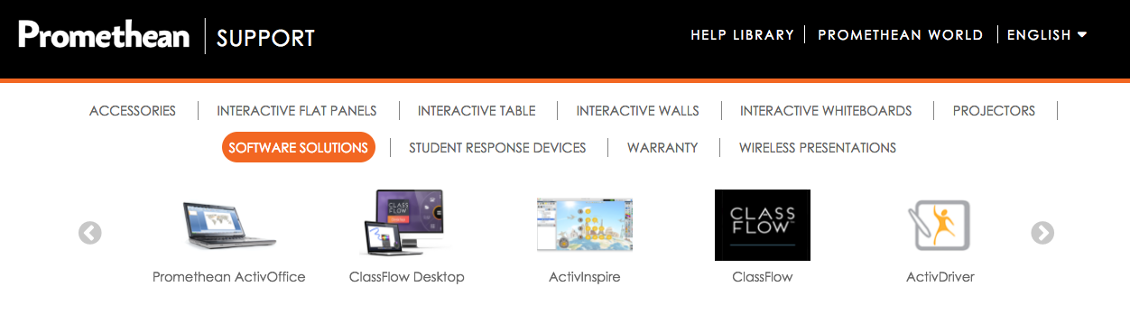

- Click on ‘ActivDriver’ to go to a screen with downloading options. Select the link for the computer you are working on (teacher Mac= Download for Mac OS X, desktop Windows computer= Download for Windows 64-bit).

- When that download begins, you can click on the ‘ActivInspire’ button. Select ‘Download ActivInspire.’
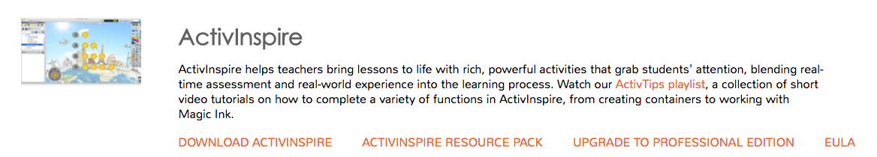

- You’ll be prompted to enter some information such as your operating system and your email. Fill this in and click ‘Download ActivInpire.’
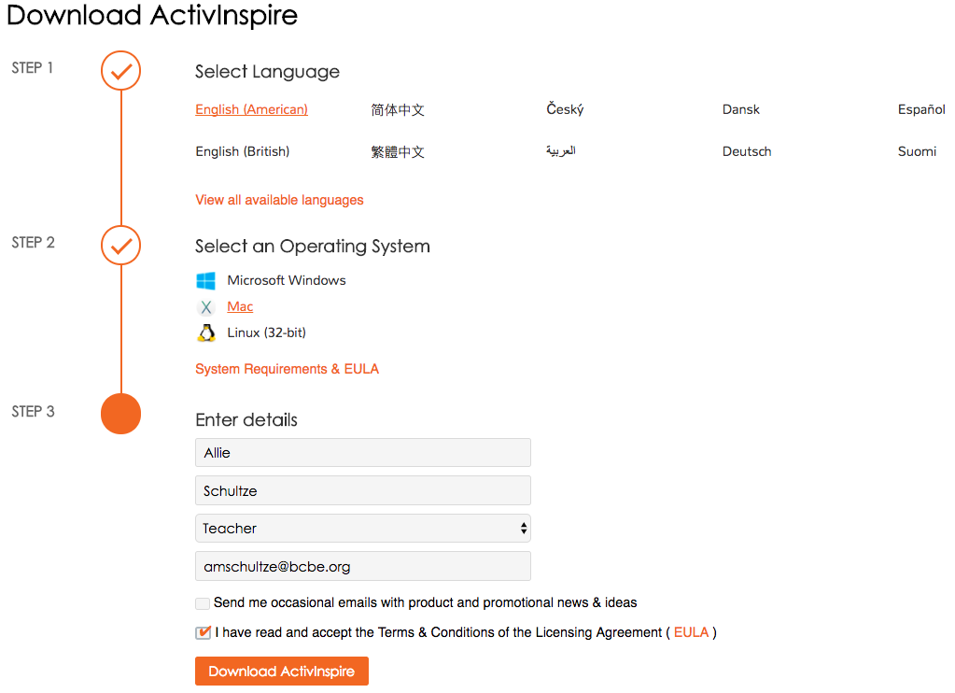

- Once the programs have finished downloading (ActivInspire usually finishes first), open it from your download folder or wherever you saved the download.

- A new window will appear with a box icon that says ActivInspire. If you are installing this software on a Mac, RIGHT CLICK (two-finger click with the trackpad or hold the the ‘control’ key while clicking) on this icon. Select ‘Open.’
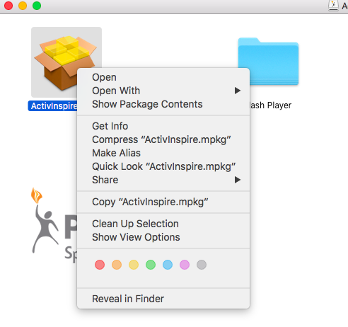

- A notification will appear stating that the program is not from the Mac Store, click ‘Open.’
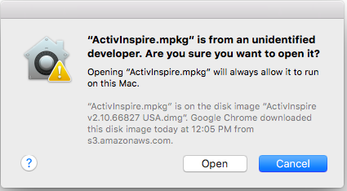

- Follow the prompts to install the software.

- Repeat steps 5-8 for the ActivDriver.

When opening ActivInspire for the first time, you might receive a message that your Java is out of date. Don’t panic, click on the button that says ‘More Info’ and follow the prompts to download the updated version. The steps should be similar to what you just did to install the Promethean software.

When you’re updated and able to open the ActivInspire software, you’ll be greeted with a registration window for your program. Enter your info and the school district. It will ask for a product key. This may be found on the sticker in the bottom corner of your board, or on a small tab on the back of the bottom left corner of the board. If you do not have a sticker or tab, please email Allie and she will get you a product key.

When you have finished installing ActivDriver, you will see a small square with a red ‘x’ appear in your top tray. This red ‘x’ will turn orange when you plug the USB cable from your board into your computer. While your board is plugged into your computer, you can click on this square to ‘calibrate’ your pen so the touch matches your cursor when using the Promethean pen on the board.

You should now be able to use your Promethean board. If you run into trouble, please submit a work order and Allie will be in contact with you.

