Change Password – MacBook

Follow the instructions below to change your email/network/computer password.

It is very important that you do this while connected to the school’s WiFi. Do not attempt to change your password unless connected to the school’s WiFi (BCAWiFi). Do NOT attempt this at home.

1 | Think of a new password to use. Your new password must be at least 8 characters long, with a mix of letters and numbers. For example, your new password might be “balance3”.
2 | Log into your Macbook while connected to the local school network (BCAWiFi).
3 | Click on the Key  icon at the top of your desktop (near the wifi indicator, battery indicator, clock) and then select Change Password. | 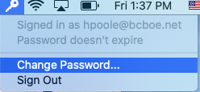
4 | Type in your Old password, and then your new password in the fields provided.  Retype your new password in the “Verify” field and then click “Change Password”. | 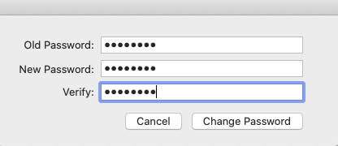
5 | You should get the following message to show that you were successful. Click OK to proceed. | 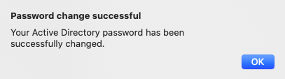

That’s it.. you’re done! Use your new password from this point forward to log into your computer and to log into the employee portal. Call the Help Desk if you have any trouble with this. 251-970-4400.

