Change Password – MacBook

Follow the instructions below to change your email/network/computer password.

It is very important that you do this while connected to the school’s WiFi. Do not attempt to change your password unless connected to the school’s WiFi (BCAWiFi). Do NOT attempt this at home.

Do this at the end of the school day, just before leaving to go home.

1 | Think of a new password to use. Your new password must be at least 8 characters long, with a mix of letters and numbers. For example, your new password might be “balance3”.
2 | Log into your Macbook while connected to the local school network (BCAWiFi).
3 | Click on the Key icon at the top of your desktop (near the wifi indicator, battery indicator, clock) and then select Change Password. | 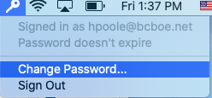
*Note – If you do not see the Key icon at the top of your desktop, skip to the
section called “Changing Your Password If You Do Not See the Key” at the end
of this document.
4 | Type in your Old password, and then your new password in the fields provided.  Retype your new password in the “Verify” field and then click “Change Password”. | 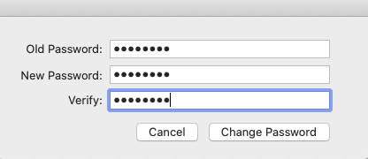
5 | You should get the following message to show that you were successful. Click OK to proceed. | 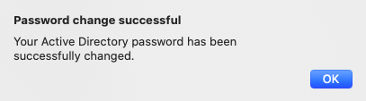
6 | Click on the Apple icon at the top left of your desktop and then log out of your MacBook. | 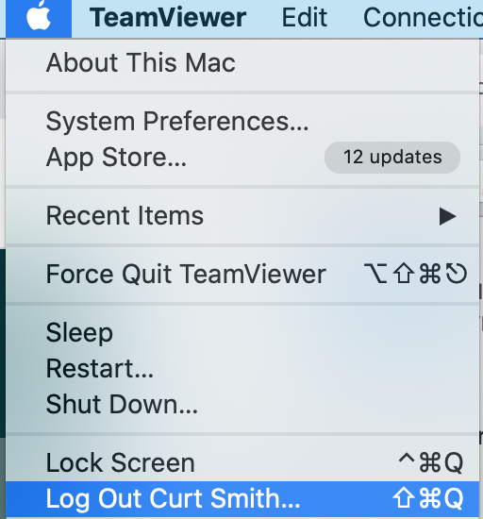
7 | Wait at least one hour, and then log back in using your new password. (This can be at home, or on campus)  The next time you attempt to use the Macbook while on campus you will be prompted to update the password used to join the BCAWIFI network.  Type in your new password, and then click OK.  YOU ARE DONE! | 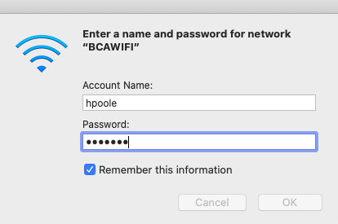
*Changing Your Password If You Do Not See The Key.
Do the following ONLY if you did not see the “Key” icon at the top of your screen in step 3 above.

*4 | Click on your name in the upper right corner of the Finder menu bar and select “Users & Groups Preferences.” | 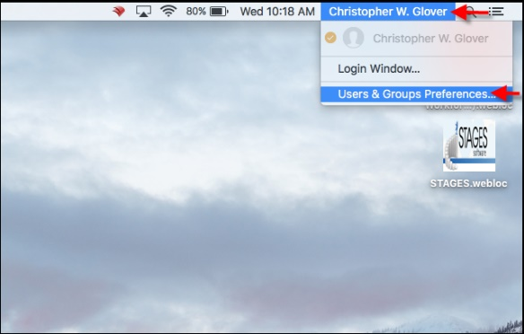
*5 | Select “Change Password.” | 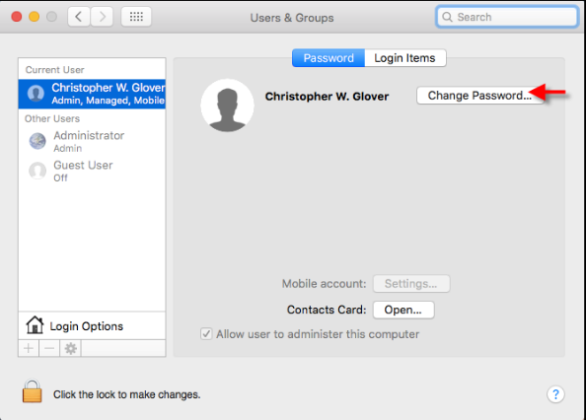
*6 | Enter your “Old Password” in the top text box and your new password in twice. Click the “Change Password” button when you are finished. | 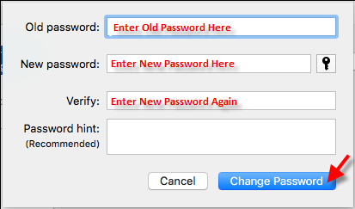
*7 | Restart your computer. Enter the new password to login. Update the password as prompted  by various programs, such as Microsoft Outlook.  YOU ARE DONE!

